Credit Default Status Prediction

Abstract— The viability of financial institutions is seriously threatened by credit default, which frequently happens when borrowers are unable to fulfil their repayment commitments. Manual assessments and simple credit scoring systems are the mainstays of traditional credit risk assessment techniques, which are laborious, ineffective, and frequently erroneous. In order to improve accuracy and decision-making speed, this research uses machine learning and deep learning techniques to present a comprehensive, automated solution for credit default prediction. Using Random Forest and Neural Network models trained on borrower financial, demographic, and credit-related characteristics, we created a strong categorization system. With a goal of at least 85% classification performance, the models were assessed to guarantee high accuracy and adjusted for the best possible predictive power.
Keywords—Random Forest, Neural network, deep learning, accuracy

Introduction
Financial risk management needs accurate credit default prediction which allows companies to determine whether debt-paying borrowers will default on their obligations. Financial institutions can reduce risks while allocating funds effectively to preserve economic stability because of precise predictions. Since its inception this field shifted from basic statistical approaches to sophisticated machine learning methods because of enhanced financial system complexity and data access.

Advances in artificial intelligence and the growing availability of financial data have made machine learning (ML) and deep learning (DL) effective methods for automating and enhancing the precision of credit default prediction. Compared to traditional approaches, these technologies allow models to extract intricate patterns from borrower data, providing more accurate and immediate insights.

A. Aim:
The aim of this project is to use machine learning and deep learning techniques to create an intelligent and understandable credit default prediction system. By automating the prediction of borrower default risk and offering interpretable insights through an interactive web-based dashboard, the system aims to improve the precision, openness, and effectiveness of credit risk assessment procedures for financial institutions.
B. Objectives:
- To build a classification model for predicting credit default status with at least 85% accuracy.
- To Improve classification performance with a deep learning model (Neural Networks).
- To introduce explainable AI (SHAP/LIME) to understand model predictions.
- To deploy a secure web-based credit risk assessment dashboard.

Literature Review
The start points for constructing credit default predictions relies on statistical models. Discriminant analysis and logistic regression served as early methods which used financial ratios along with indicators to spot defaulting entities from non-defaulting ones. Such models were easy to interpret but failed to detect the non-linear connections across the data. The models faced performance limitations during predictions especially when operating in complex financial situations [1].

The ineffective performance of traditional models created an opportunity for using ML techniques to enhance credit risk assessment. The three popular ML alternatives for large-scale data analysis included Support Vector Machines (SVMs), decision trees, and artificial neural networks (ANNs) because of their capability in discovering complex non-linear patterns. Advanced prediction methods led to enhanced default estimation through their competence in working with large datasets and identifying sophisticated variable connections. The problems of overfitting and interpretability issues still needed improvement in addition to further advancements [2].

Multiple algorithms were combined through ensemble methods by researchers to address individual model weaknesses because predictive performance suffered from their limitations. LightGBM and XGBoost have become popular because they efficiently process large credit data with high accuracy. Multiple decision trees are integrated in these models to achieve better generalization and minimize overfitting problems. The combination of statistical approaches with ML techniques through hybrid models has emerged as a proposed solution to use both paradigms while finding an equilibrium between interpretability and predictive capabilities [3].

Deep learning has introduced additional transformations to the credit default prediction process. The multilayer structure of deep neural networks allows them to extract hierarchical data representations which suits their use in processing complex credit behavior sequencing. Deep learning models have shown better results than traditional ML algorithms in two specific use cases: unstructured data analysis and situations where feature engineering proves difficult. The opaque internal functioning of advanced models creates important challenges regarding explainability since financial institutions need complete transparency for proper decision making [4].

Dataset
The data is being gathered from Kaggle [5]. This data contains information of around 1000 customers. There are around 84 features in the data. Important features in the data are as follows:
- CREDIT_SCORE: Numerical score representing customer’s creditworthiness.
- DEFAULT: Binary label (1 = Default, 0 = No Default).
- INCOME: Customer’s total income in the last 12 months.
- SAVINGS: Total savings in the last 12 months.
- DEBT: Total outstanding debt.
- R_SAVINGS_INCOME: Ratio of savings to income.
- R_DEBT_INCOME: Ratio of debt to income.
- R_DEBT_SAVINGS: Ratio of debt to savings.
- Expenditure Categories: GROCERIES, CLOTHING, HOUSING, EDUCATION, HEALTH, TRAVEL, ENTERTAINMENT, GAMBLING, UTILITIES, TAX, FINES.
- T_{GROUP}_6: Total expenditure in a category over the last 6 months.
- T_{GROUP}_12: Total expenditure in a category over the last 12 months.
- R_{GROUP}: Ratio of T_{GROUP}6 to T{GROUP}_12.
- R_{GROUP}INCOME: Ratio of T_{GROUP}_12 to INCOME.
- R_{GROUP}SAVINGS: Ratio of T_{GROUP}_12 to SAVINGS.
- R_{GROUP}DEBT: Ratio of T_{GROUP}_12 to DEBT.
- CAT_GAMBLING: Gambling behavior (none, low, high).
- CAT_DEBT: Presence of debt (1 = Yes, 0 = No).
- CAT_CREDIT_CARD: Credit card ownership (1 = Yes, 0 = No).
- CAT_MORTGAGE: Mortgage ownership (1 = Yes, 0 = No).
- CAT_SAVINGS_ACCOUNT: Savings account presence (1 = Yes, 0 = No).
- CAT_DEPENDENTS: Whether the customer has dependents (1 = Yes, 0 = No).

Methodology
In the methodology section, there is a detailed description of the all the steps which are carried out for performing the classification task and making the predictions. It includes data cleaning, preprocessing, feature selection, developing prediction models, making predictions, evaluating the model and developing a web based interactive dashboard.

Data Pre-processsing:
In this step the data is cleaned so that the data is in appropiate format to be used as an input for the machine learning models. Initially the data is loaded by using Pandas library and then the data is displayed using the basic data.head() function. The data is checked for null values and it is found that there are no null values present in the data. The describe() function is used to check the statsitical parameters in the data. Mean, median, minimum or maximum values in the data are properly analysed by using the statistical analysis.
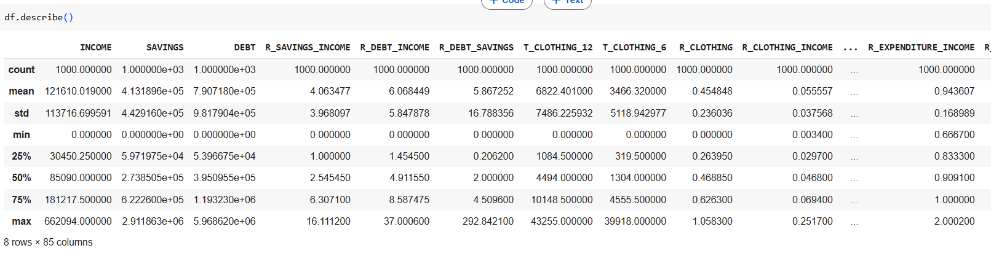
- Statistical analysis of data
There are some categorical attributes in the data which is important to be converted into numeric data type which is done appropriately by using Label encoding method. By using Label encoding, the categorical attributes are converted into numeric by assigning numeric values to the columns. The standard scaler method is used for standardizing the data so that all the data is under one specific value. The SelectKBest function is being used for selecting the 10 best features which could be used as an input for training the models.

Exploratory data analysis
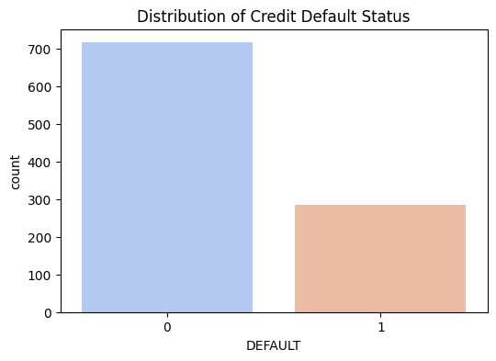
Fig. 3. Distribution of credit default status
From the distribution plot of the credit default status, it could be analysed that the people who are not defaulters are maximum as compared to the ones who are defaulters.
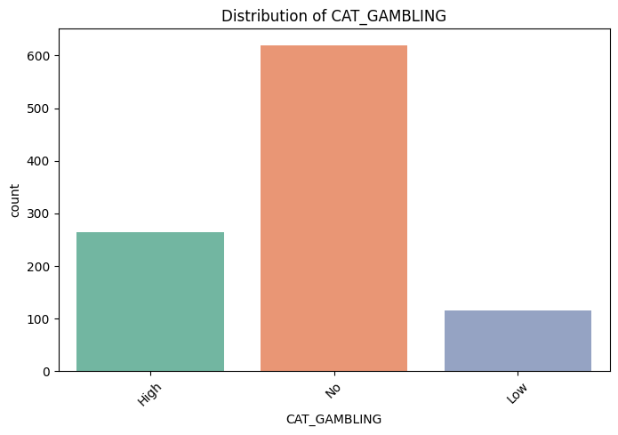
Fig. 4. Distribution of Gambling
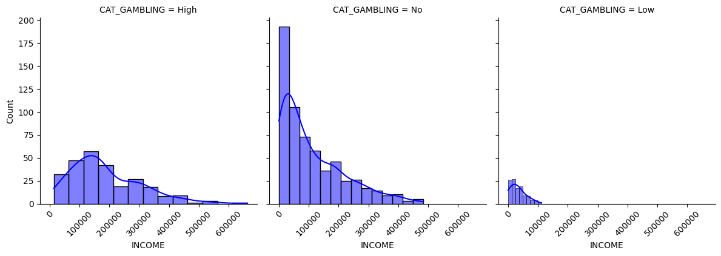
Fig. 5. Gambling attribute distribution plot
The next analysis shows that thee is no gambling with the credit cards followed by high gambing which is then followed by low gambling.
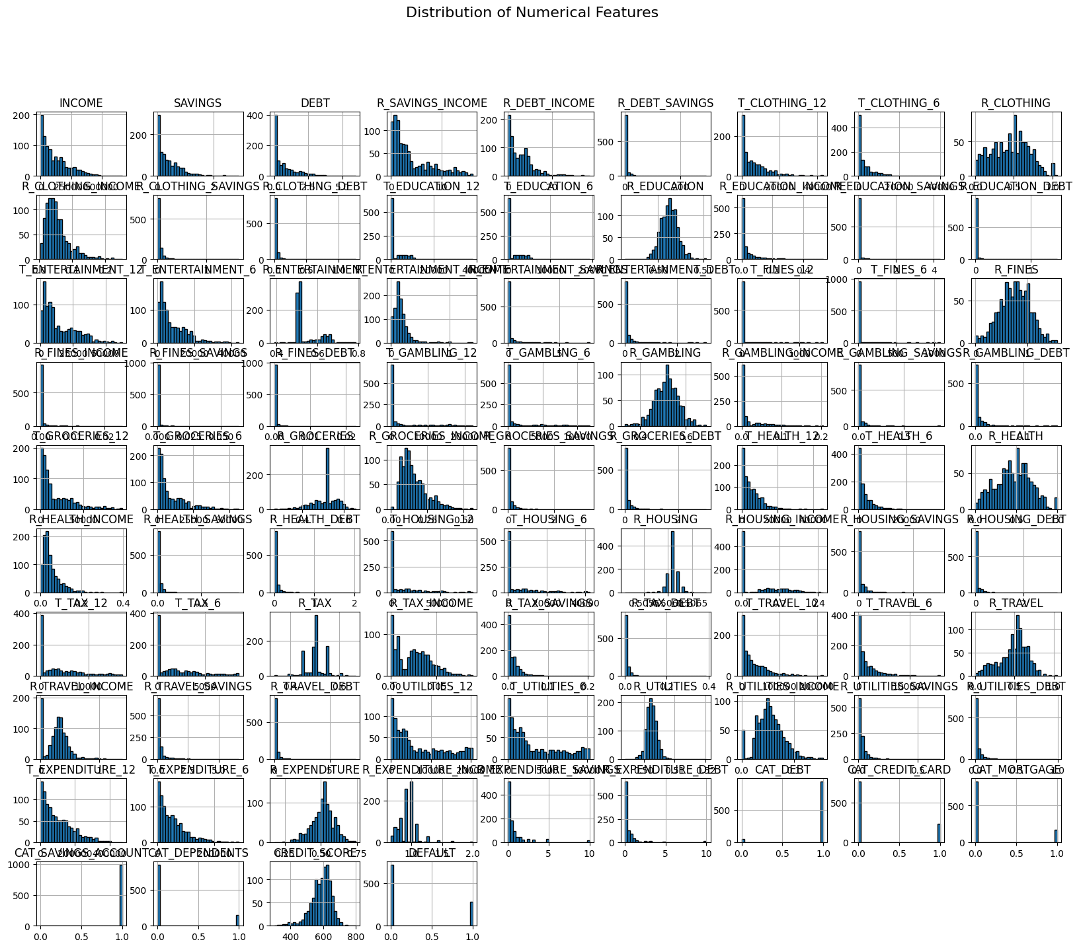
Fig. 6. Distribution of numerical features
Using histograms, this plot displays the distribution of numerical characteristics in the credit default dataset. A distinct aspect, such as income, savings, debt, and their ratios (e.g., R_DEBT_INCOME), is represented by each subplot. The majority of variables are right-skewed, meaning that most values are concentrated at lower ranges. Examples of these variables are INCOME, SAVINGS, and DEBT. Features that are more uniformly distributed or binary include CREDIT_SCORE and DEFAULT. Understanding data size, skewness, and the necessity of transformation or normalization prior to model training are all aided by this approach.
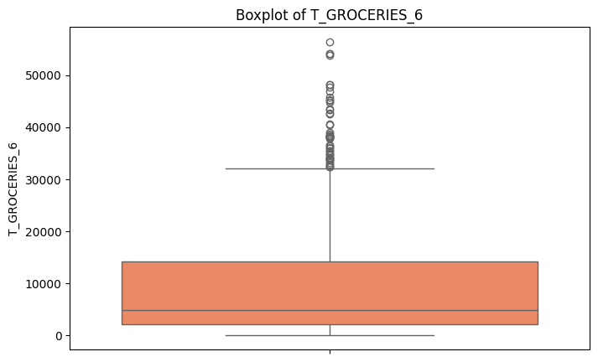
Fig.7. Box plot
The distribution of the T_GROCERIES_6 variable, which represents grocery spending over a six-month period, is shown in this boxplot. The horizontal line inside the box, or median, is around 5,000. The interquartile range (IQR) shows the middle 50% of the data which is displayed by, ranges from around 2,000 to 13,000. Many outliers are found above the top whisker, with some values over 50,000, suggesting that expenditure can occasionally be quite high.
The grouping of outliers and the lengthy upper whisker indicate that the data is right-skewed. This implies that some people have extremely high food prices, while the majority pay a normal amount.
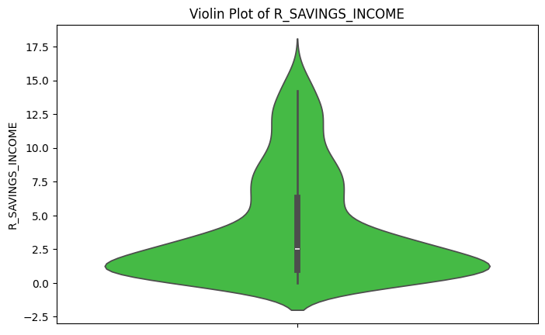
Fig.8. Violin plot
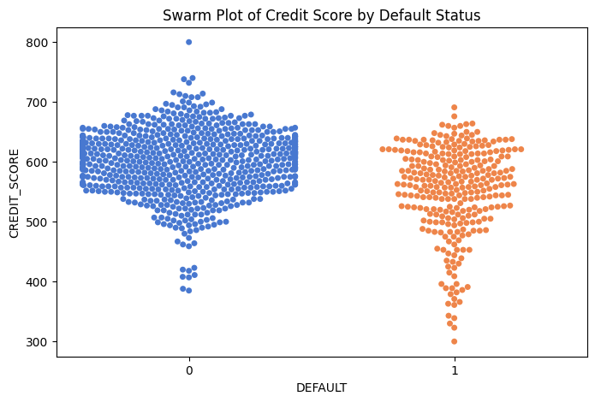
Fig. 9. Swarm plot
The swarm plot shows the distribution of the defaukt status of the customers where it is found that most of them are under the category of no default while there are some customers who are the defaulters.

Model development for sentiment classification
Random forest regression model and Neural network are used for making the predictions. For that initially the target variable is selected and assigned to y variable while all other selected features which are to be used for training the model are considered in X attribute. The whole data is divided into two sets, training data and testing data. 20% of the data are used for testing the model while remaining 80% of the data are used for training the model. Then the two algorithms are being implemented.

Random Forest model is the advanced model which involves the combination of number of decision trees. It is one of the ensemble methods which is used for classification as well as regression problems. This model works efficiently by reducing the overfitting of the model and ultimately increases the accuracy of the model. The random forest model averages the predictions and use bootstrapped samples. The whole data is divided into different subsets and for each subset of data a decision tree is developed and finally the results from all the decision trees are combined together to get the final prediction of a random forest model [6].

Using certain financial ratios and categorical factors, such as credit card usage and credit score, the algorithm creates a neural network model to forecast credit default. First, the data is cleaned, the features are scaled, and the data is divided into training and testing sets. Next, dropout layers are added to a multi-layer neural network to avoid overfitting. Accuracy, a confusion matrix, and a classification report are used to assess the model's performance after it has been trained using binary cross-entropy loss for 50 epochs and Adam optimizer is being used. In order to evaluate the model's performance over time, the training history is finally displayed [7].

The neural network is then fine tuned to get a better result which also generalizes the capabilities of the credit card predictions. The model was able to identify more intricate patterns in the financial data by expanding the architecture by adding additional neurons to each of the three thick layers (128, 64, and 32 neurons, respectively). To stabilize and speed up the training process, batch normalization layers were added after the first two dense layers. Additionally, by randomly deactivating a subset of the neurons during each training iteration, dropout layers with increasing rates (0.4, 0.3, and 0.2) were positioned to minimize overfitting. In order to improve convergence by enabling more precise updates to the model weights, a lower learning rate of 0.0005 was used. Based on the validation loss, early stopping was used to further avoid overfitting and guarantee optimal performance.

A pre-trained Random Forest model is used in this Streamlit-based web application to estimate credit default risk through an interactive dashboard. Key financial indicators that users may add include credit card ownership, credit score, debt-to-income ratio, debt-to-savings ratio, and different sorts of debt (health, grocery, entertainment, etc.). When the "Predict Default Risk" button is clicked, the application analyses the data and classifies the borrower as having a high or low default risk based on the loaded model. It is a useful tool for people or financial organizations assessing loan applications because of its user-friendly interface, which enables real-time risk evaluation.

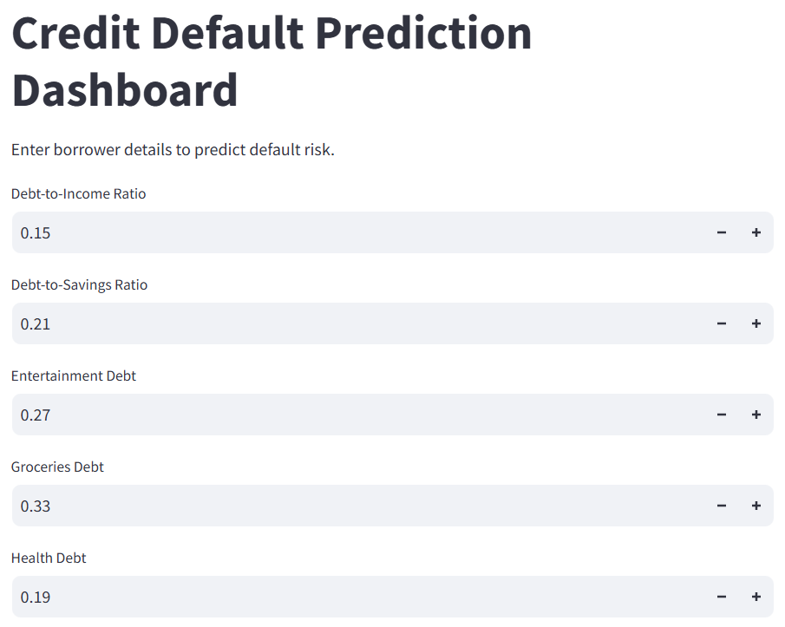
Fig.11. Dashboard for credit default prediction
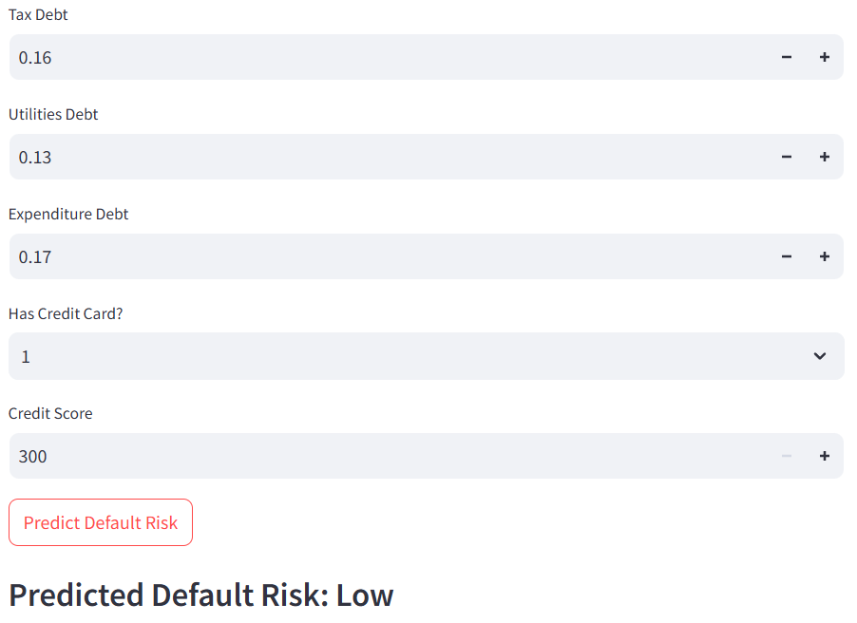
Fig.12. Dashboard for credit default prediction output

Evaluation results
The models are evaluated using the evaluation metrics. It helps in understanding which model has performed well.
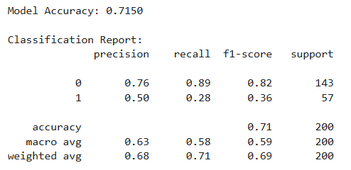
Fig.11. Evaluation results of Random forest model
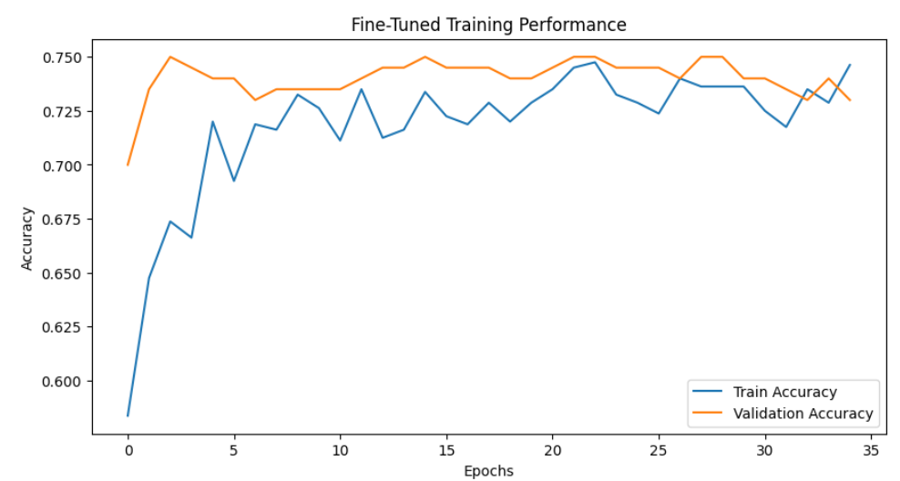
Fig. 12. Evaluation result of fine tuned neural network
It is found that the random forest regression model is giving an accuracy of 71% while that of the fine tunes neural network is 74%.
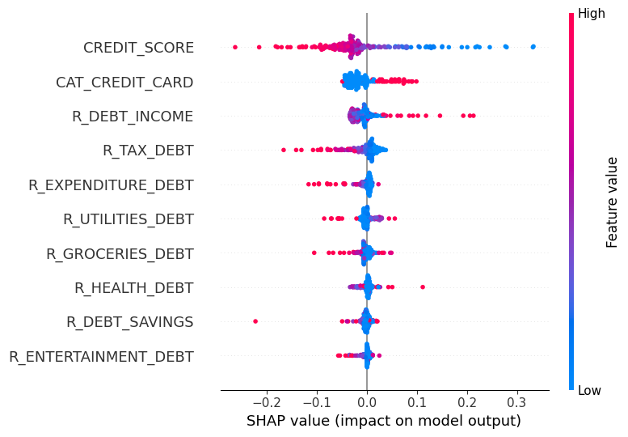
Fig. 10. SHAP explainer
This SHAP explainer is one of the important tools which helps in understanding why the output of the machine learning model has given this certain prediction and also helps in finding the contribution of each feature to the final decision. It is mainly based on some game theory which helps in assigning a SHAP value to each of the features that also quantifies its impact which is either positive or negative on the predictions.

Conclusion
This project effectively used explainability methodologies, feature engineering, sophisticated modelling, and data preparation to create a reliable and comprehensible credit default prediction system. To precisely forecast the chance of loan default, we trained and optimized both conventional machine learning models (such as Random Forest) and deep learning models using a carefully chosen collection of financial and behavioural characteristics.
The predictive model is being implemented with the help of the interactive Streamlit dashboard which helps the model accessible to the real world which helps the stakeholders to put input which would help in quickly assessing the risk. This helps in having a good predictive model which could be appropriately used in the form of a dashboard for observing the credit default.

References

- Anton Markov, Z. S. (2022). Credit scoring methods: Latest trends and points to consider. Science Direct.
- Kimani, G. W., Mwai, J. K., & Mwangi, E. (2024).
- Yao, J., et al., (2022)
- Dastile, X., & Celik, T. (2021), Making Deep Learning Based Predictions for credit scoring explainable.
- https://www.kaggle.com/datasets/conorsully1/credit-score
- Random Forest Algorithm in Machine Learning by Shruthi: https://www.analyticsvidhya.com/blog/2021/06/understanding-random-forest/
- Neural Network in Machine Learning by Varin: https://www.analyticsvidhya.com/blog/2022/01/introduction-to-neural-networks/

